SDL on Mechanical Advantage and Efficiency of Levers
What is a Lever?
A lever is a simple machine made of a rigid bar that can rotate around a fulcrum (pivot point).
Levers help us lift or move loads with less effort by amplifying or changing the direction of force.
Terms Related to a Lever
Term | Definition
Fulcrum (Pivot) | The fixed point about which the lever rotates.
Load (L) | The resistive force or weight to be moved. (Unit: Newton N)
Effort (E) | The applied force used to move the load. (Unit: Newton N)
Effort Arm | Distance between the effort and the fulcrum.
Load Arm | Distance between the load and the fulcrum.
Mechanical Advantage (MA) | The ratio of the load (output force) to the effort (input force). It shows how much a machine multiplies the applied force. (MA = L/E = Effort Arm/Load Arm)

Types of Levers
Levers are classified based on the relative positions of the Fulcrum (F), Load (L), and Effort (E).
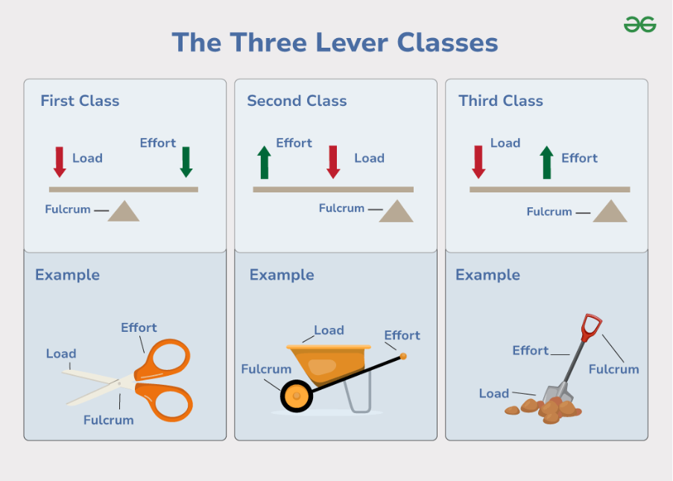

Levers and Mechanical Advantage
Type | Description | Examples | MA
First-Class Lever | Changes direction of force; may increase force or speed. | Seesaw, scissors, crowbar, pliers | > 1(Force multiplier), = 1(only changes direction), or  < 1 (speed multiplier)
Second-Class Lever | Always increases force; effort arm > load arm. | Wheelbarrow, nutcracker, bottle opener, door | > 1 (Force multiplier)
Third-Class Lever | Increases speed or distance; needs more effort. | Tongs, fishing rod, shovel, bat, tweezers | < 1 (Speed or distance multiplier)
- MA > 1 → lever multiplies force (lifts heavy loads).
- MA < 1 → lever multiplies speed or distance.
- MA = 1 → lever only changes direction of force.

